ERROR: Could not install packages due to an OSError: [Errno 2] No such file or directory: 'C:\\Users\\Admin\\AppData\\Local\\Packages\\PythonSoftwareFoundation.Python.3.10_qbz5n2kfra8p0\\LocalCache\\local-packages\\Python310\\site-packages\\tensorflow\\include\\external\\com_github_grpc_grpc\\src\\core\\ext\\filters\\client_channel\\lb_policy\\grpclb\\client_load_reporting_filter.h' HINT: This error might have occurred since this system does not have Windows Long Path support enabled. You can find information on how to enable this at <https://pip.pypa.io/warnings/enable-long-paths>

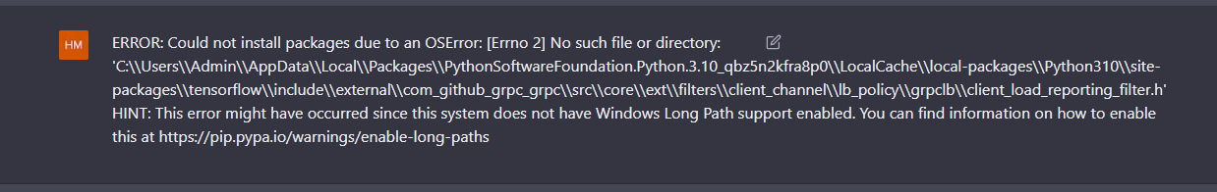

Fix

HKEY_LOCAL_MACHINE\SYSTEM\CurrentControlSet\Control\FileSystem

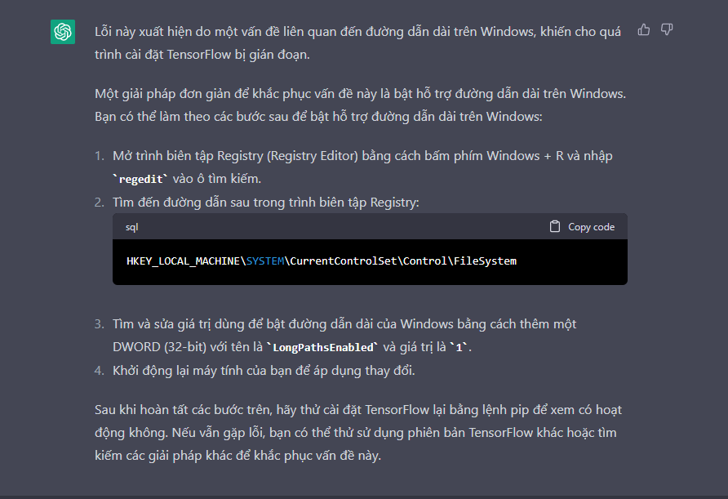

Chỉnh ntn xong reset máy

